Requirements
- Login & password for Name.com
- Web browser (Firefox or Chrome recommended)
- Club debit card
- Approval from club to pay for renewal (should be included in budget)

Logging into Name.com
- Open https://name.com in your web browser.
- Select the Log in button at the top right.
- Enter the username and password (should be in the KeePass file).
- Select Log in.
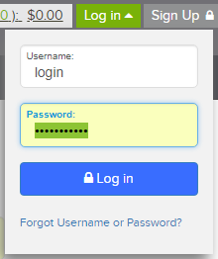

Renewing Domains
- Select the Go to Renewal Center button (if available).
- Select the top check box on the left to select all domains.
- Select the Renew Selected Domains button. A message showing that the selected products were added to your cart should appear.
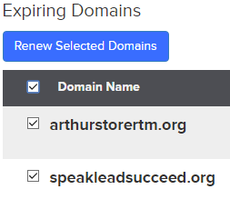
- Select the Cart link at the top right of the page.
- In the promo code field, enter the code PRIVACYPLEASE, then select Apply Promo. The Advanced Security + Privacy Renewals should be free.
- Select Next Step: Payment >
- Enter the club debit card info.
- Uncheck Yes, save this credit card now to enable automatic renewal on all your products and domains (the club has to approve spending the money, plus you don’t get the discount if automatically renewed).
- Check the I agree to Terms & Conditions and I have read and acknowledge the Partner Privacy Policy boxes on the right.
- Select the Complete Order button.

Follow-Up Steps
- Name.com should mail a receipt; save it for club records as needed.
- Verify both domains work by entering them in your web browser.

