Site URL: https://www.mondaynighttoastmasters.com/

Login to Site Administration
- On the left menu bar, select Login as site admin.
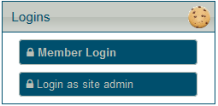
- In the window that appears, enter the club number and admin password (see KeePass file), then select Login.
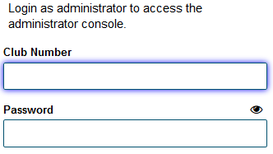
- If a New Messages window appears, select Keep These and Close.
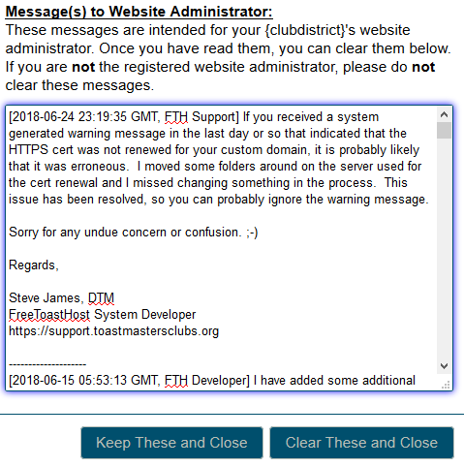
- The Logins section on the left menu bar should change. Select Launch admin console.
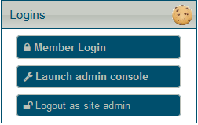
- Optional: Set a size for the Site Administration window with the S, M, or L buttons in the top right corner.

Updating Floater Messages
At the top of the month, you’ll need to update the guest floater message to include upcoming meetings for the current month and the next month.
  - Login to Site Administration if not already logged in.
  - Select the Floater Messages tab.
  - Use the Non Member Message field with the current month and next month’s meetings. For example, if it’s June, you should have something like:
Next Meetings: June 7th, 14th, 21st, & 28th; July 11th, 18th, & 25th
  - OPTIONAL: You may want to copy the text here to paste into the home page. (highlight the text and use Ctrl+C)
  - Select Save when finished. 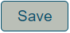

Updating the Home Page
In addition to updating the floater message at the top of the month, you’ll want to update the home page’s upcoming meetings box. You can also use this process to update the home page as desired/needed.
  - Login to Site Administration if not already logged in.
  - Select the Home Page tab.
  - To update the “Next Meetings” box, highlight the text. If you copied the Next Meetings text from updating the floater message, you can use Ctrl+V to paste. (If you make a mistake, use Ctrl+Z to undo) Otherwise, enter the Next Meetings info.
  - Make any other changes as needed.
  - Select Save when done.

