NOTE: There are three items to change: The Site URL just below, and the e-mail aliases at the end of this document.

Site URL: [Insert Your Site Here]

Login to Site Administration
- On the left menu bar, select Login as site admin.
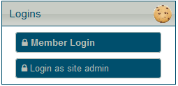
- In the window that appears, enter the club number and admin password (see KeePass file), then select Login.
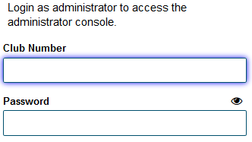
- If a New Messages window appears, select Keep These and Close.
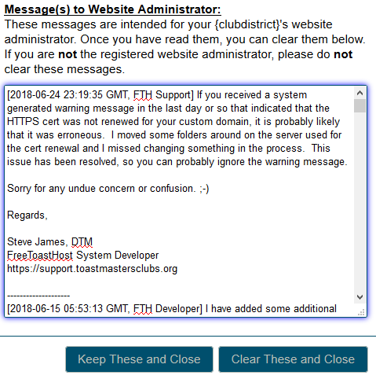
- The Logins section on the left menu bar should change. Select Launch admin console.
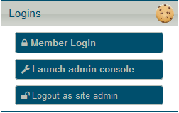
- Optional: Set a size for the Site Administration window with the S, M, or L buttons in the top right corner.

Manage Mailing Lists
- In the Site Administration window, use the Select a Module dropdown to select Membership Management. The Membership Management window will appear. 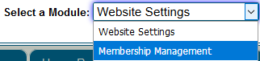
- If a window appears warning about people deletion appears, select Close.

Manage Mailing Lists – Add People to Lists
- In the Membership Management window, select the Quick Add tab. 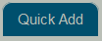
- For the Add the following people as: dropdown box, select the group you want to add people to (usually guests).
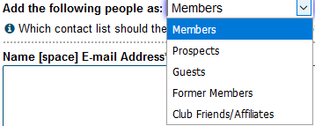
- In the blank box underneath, enter contact details. Enter one person per line. The format is <First Name> <Last Name> <E-Mail Address> <Phone # in NNN-NNN-NNNN>. For example:
John Smith jdsmith@gmail.com 123-456-7890
Jane Smith janesmith@hotmail.com 987-654-3210
- Select Save when complete.

Manage Mailing Lists – Move People Between Lists
This task is useful when guests become members and members become former members.
- Select the tab of the list you want to move members from (for example, if you want to move a guest to the member list, start on the Guests tab).
- Locate who you want to move on the list and select the check box next to their name. (You can make multiple selections if appropriate)
- From the Membership Tools dropdown box, select the appropriate Move to option. (for example, to move a guest to the members list, use Move to Members List) 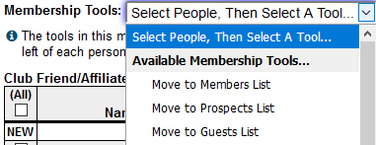
- Select Save when done.

Manage Mailing List – Edit Contact Details
- In Membership Management, select the tab of the list that contains the person you want to edit.
- Select the field you want to edit and make the appropriate changes.
- Select Save when done.

Mailing Guests & Former Membership – Fridays before the meeting
- In your e-mail client, start a new e-mail.
- Enter guests@[Your Site Domain] and formermembers@[Your Site Domain] in the To field for the message.
- Copy the text of the Guest Reminder template into the e-mail, then edit and send.

