Handout #6
“Terrific Tips to Toastmasters” from the District 55 LGM Team 2014/2015
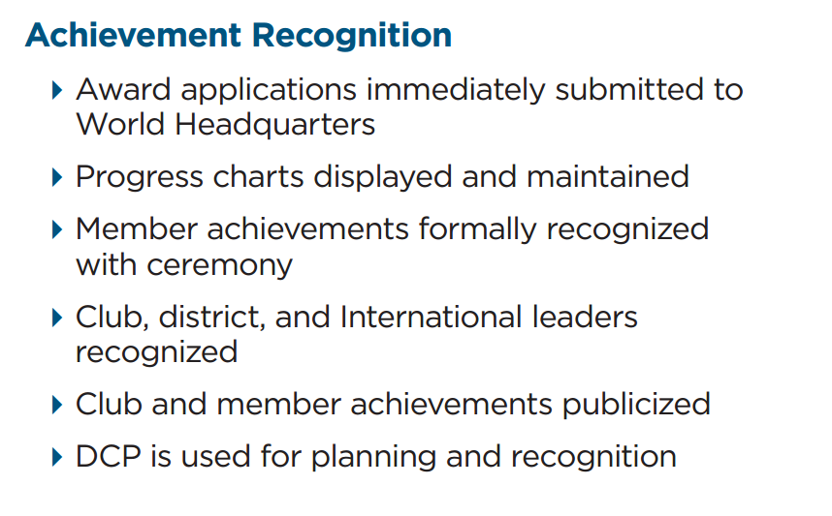
Comments: _______________________________________________________________________________________________________________________________________________________________________________________________________________________________________________________________________________________________________________________________________________
Suggestions:____________________________________________________________________________________________________________________________________________________________________________________________________________________________________________________________________________________________________________________________________

