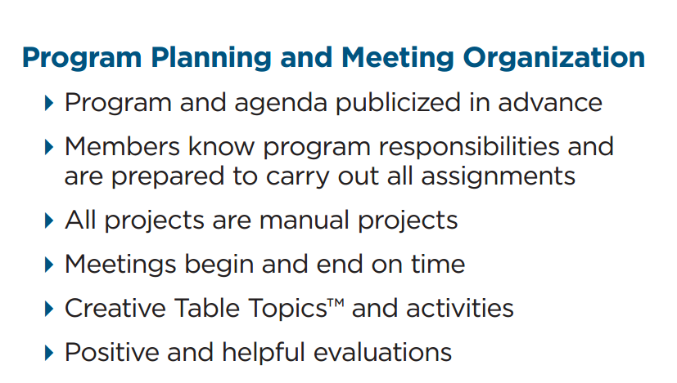
Handout #4
“Terrific Tips to Toastmasters” from the District 55 LGM Team 2014/2015
Comments: _______________________________________________________________________________________________________________________________________________________________________________________________________________________________________________________________________________________________________________________________________________
Suggestions:____________________________________________________________________________________________________________________________________________________________________________________________________________________________________________________________________________________________________________________________________

