Handout #3
“Terrific Tips to Toastmasters” from the District 55 LGM Team 2014/2015

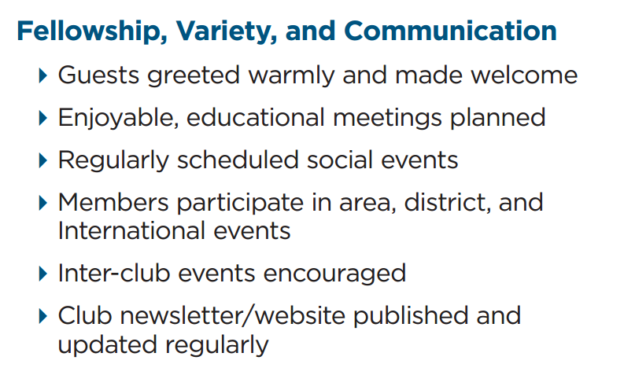

Comments: _______________________________________________________________________________________________________________________________________________________________________________________________________________________________________________________________________________________________________________________________________________
Suggestions:____________________________________________________________________________________________________________________________________________________________________________________________________________________________________________________________________________________________________________________________________

